**EXPERIMENT-3**

**Aim-** To create Docker network and attach it with Containers for connectivity.

**Procedure:**

**1)** To create your own network use command **docker network create <network-name>**. To see all the existed network use command **docker network ls**.  
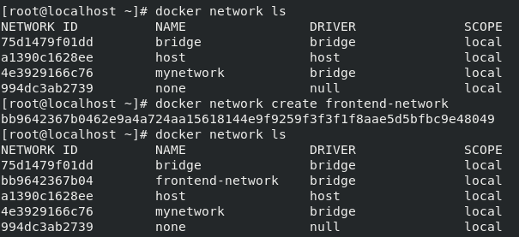

**2)** To launch a container inside a network use option  
**--net=<network-name>** while launching a container.  
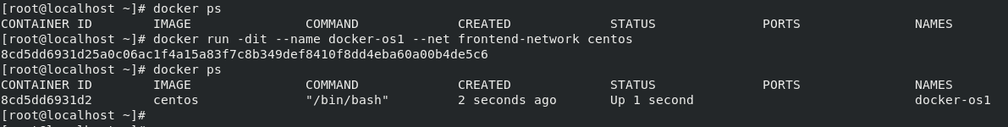

**3)** To see the network details of the container and check if it is inside the specified network use command **docker inspect**. This command gives all the details about the container. You can also use **pipe** and **grep** commands to search faster.

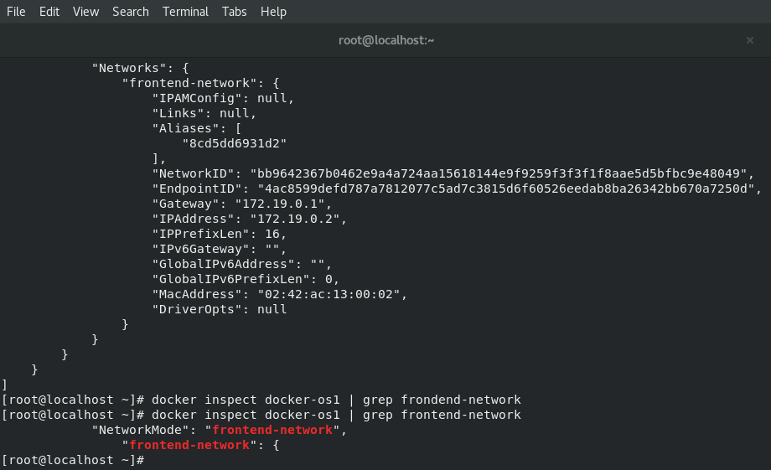

**4)** Now we will launch another container within same network as done in step-1. Two containers inside the same network can connect to each other with just container name provided. Use **ping** command from one container to ping another container from same network.  
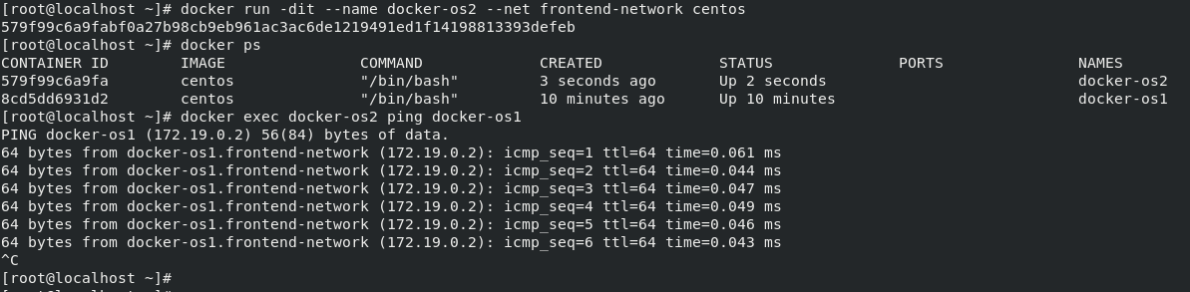

**5)** A container can be connected to more than one network at a time. For this, create another network and attach it to any one container we just created. Use command  
**docker inspect** to check it.  
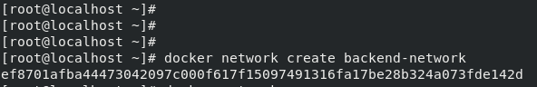  
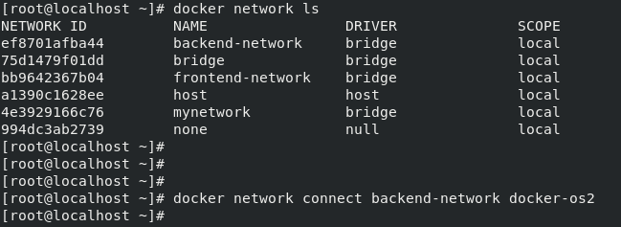  
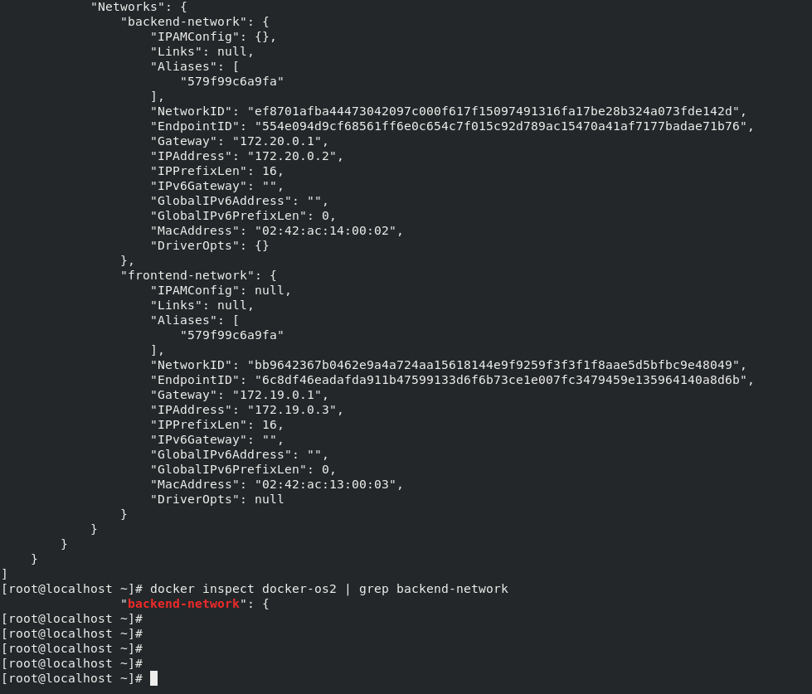

**6)** While connecting a network with a container, use option   
**--alias** to give alias to the container within the network. Now we can connect with this container using its alias name. Use **ping** command to verify it.  
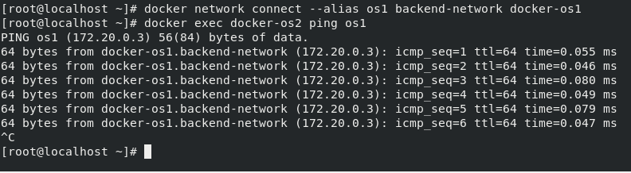

**Submitted by:**Ajay Kumar Tyagi  
500067403  
R171218008  
CSE-DevOps 2018-2022